# Exercise 1(B) - In-Lab Task

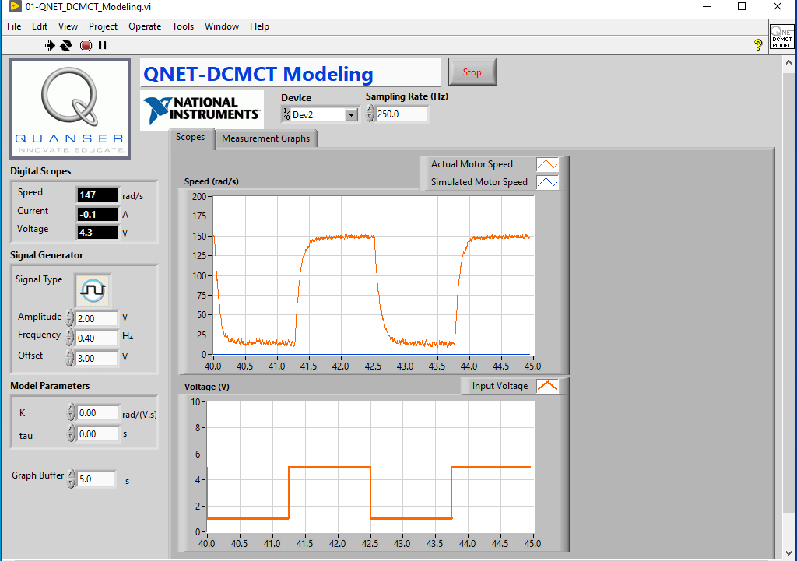

Initially, set *K* and *tau* to zero and observe only the actual motor speed. Click on the *Stop* button after steady-state is achieved (after a couple of cycles).

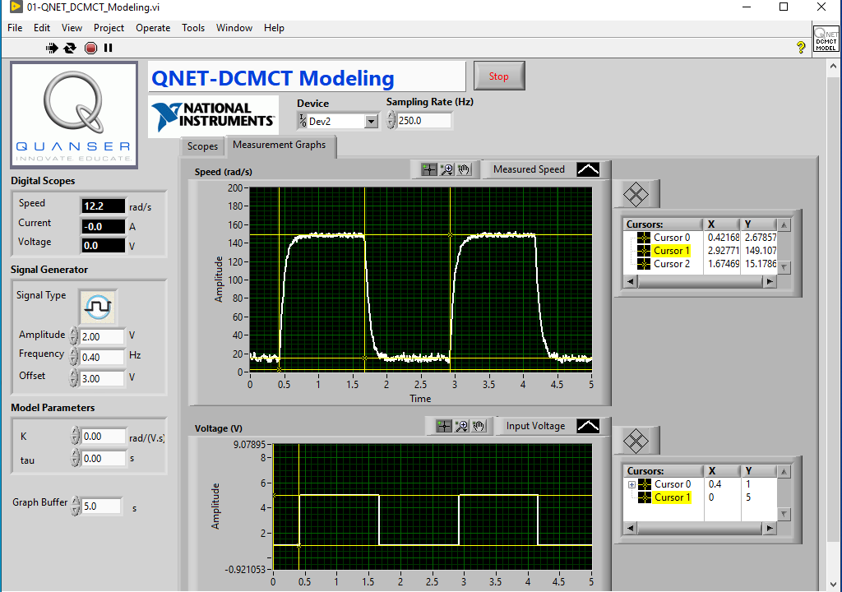

Go to *Measurement Graphs* tab and align the cursors at appropriate points of the waveform to note the corresponding values accurately. You can also add a cursor by right-clicking in the table.

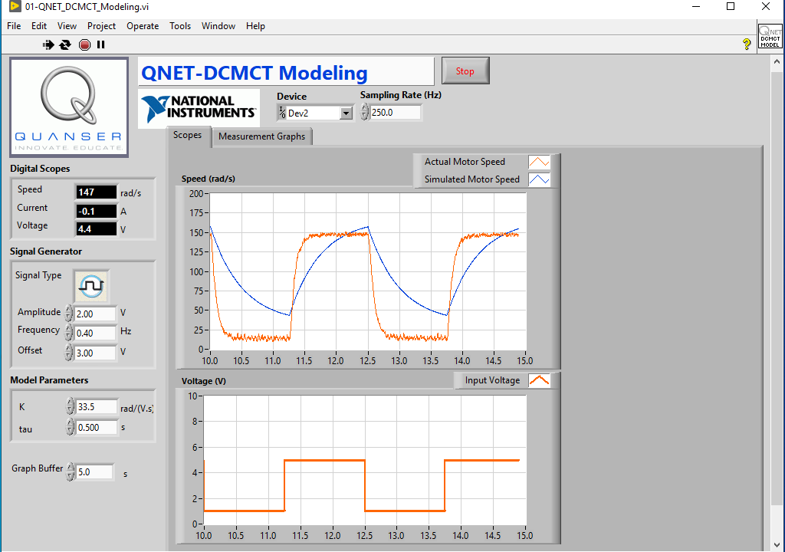

Calculate *K* and *tau* values and substitute them in *Model Parameters*. Observe the simulated response w.r.t. true motor response.

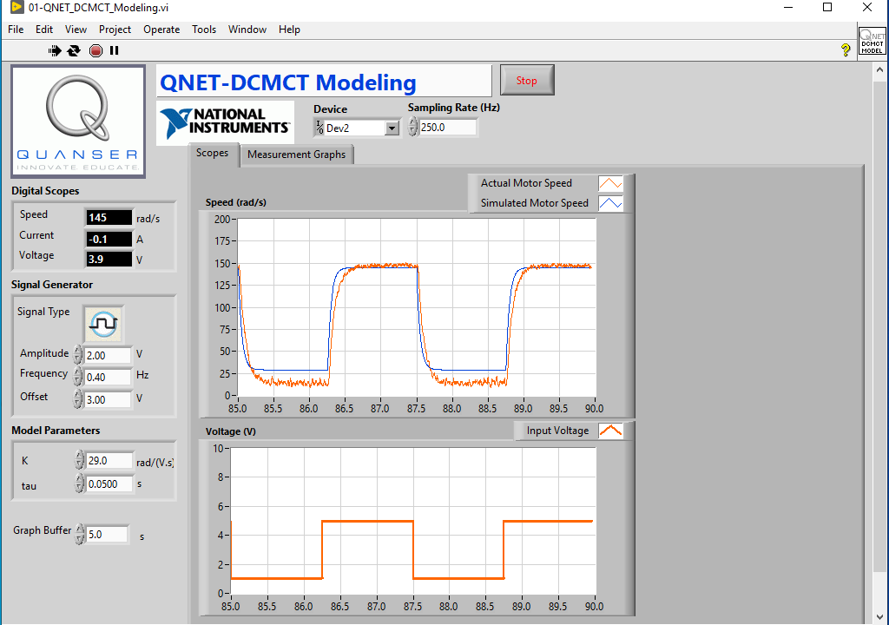

Optionally, fine-tune the *K* and *tau* values to obtain pseudo-realistic simulated response.